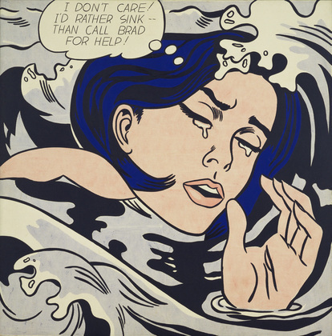
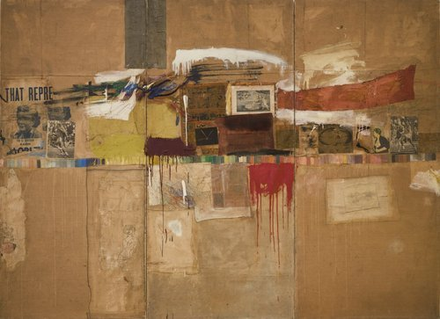
Pop Art Fact File
Notable Pop artists:
Andy Warhol, Roy Lichtenstein Ed Ruscha, Sir Peter Blake, David Hockney, Julian Opie, Patrick Caulfield, Micheal Craig Martin,

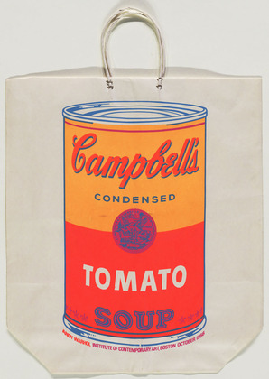
Pop art began in 1950s Britain and the United States. It was a reaction to the rise in advertising post World War Two. After the rationing stopped the companies were able to fight for customers and branding became more important. The rise in the advertising and imagery was really interesting

Pop art is named after its’ relationship to popular culture- often using imagery directly from advertising. Pop Art relies not only on the way a subject looks, but also how the audience will understand and react to it. When Andy Warhol painted a Campbell’s soup can it was something that was ubiquitous*, but removed from its mass- produced, consumer based setting.

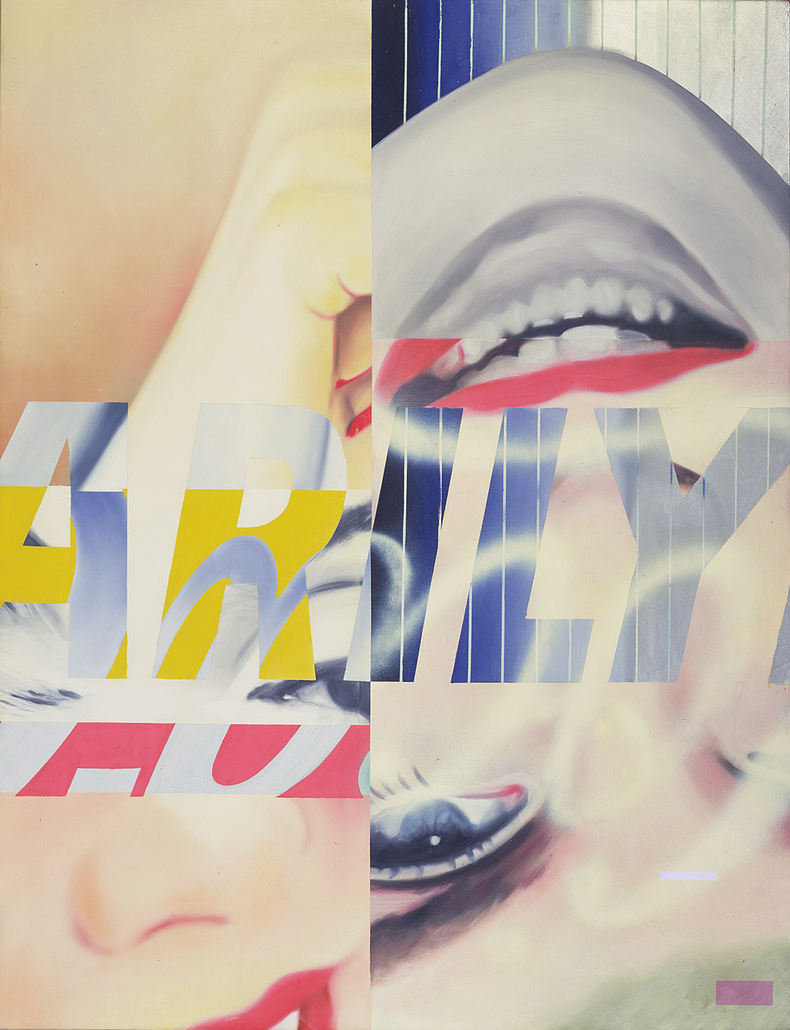
Pop art is seen as a reaction to the dominant ideas of the abstract expressionists who stopped recreating what could be seen and reduced ideas to colour and line and movement (like Mark Rothko and Jackson Pollock.) it was not based on what could be seen and universally understood, but instead was very subjective.*

*Subjective- based on opinion and situation. With a bias
*consumer – someone who buys
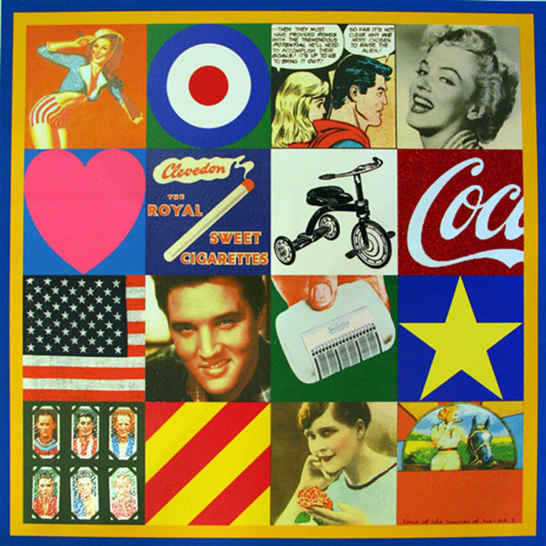
*Ubiquitous – something found everywhere

