He spoke to my IDBP students about how he explores the idea of a "SURFACE" to help with our unit. He started by showing a beautiful video of his work .
I kept some notes as he spoke in case you want to read them (I have kept them as if he wrote them, although it is not a direct quote):
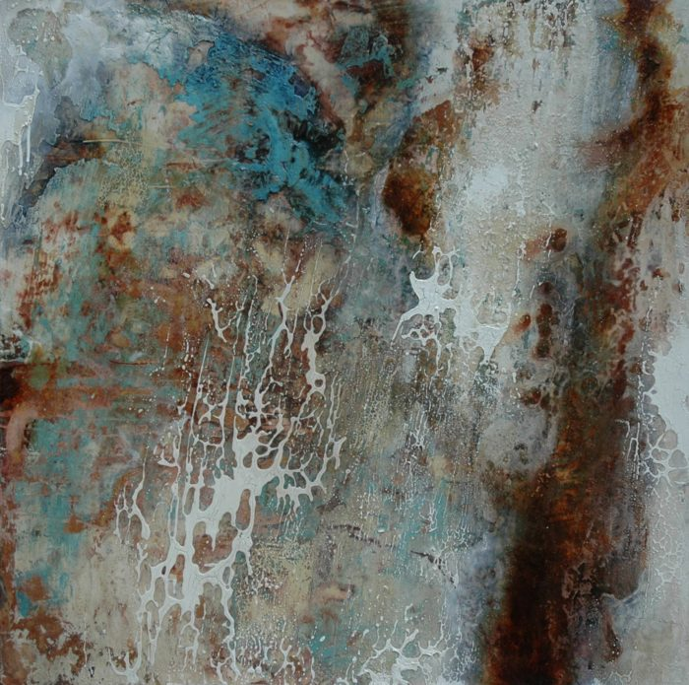
EUCALYPTUS
https://aerialperspective.wixsite.com/home/projects?wix-vod-comp-id=comp-jbaculls#
https://youtu.be/NCQHHXNPOds
I didn't want to just show what the Eucalyptus looked like- a camera could do that. I wanted to have an artistic response that shows how I appreciated it.
Rather than showing what it looks like, I have showed what I was excited by. I loved the way that the trunks twisted and grew, trunks peeling away the fresh light layers underneath. My technique replicated the surface that excites me about the bark as it wears it away.
When I first began these explorations, I was working on building my house and couldn't buy more canvas. I had a belt sander that I had been using, so I decided that I would just sand the layers down, start again and then rebuilt the surface with fresh paint. As I sanded I saw something wonderful and unexpected and realised that I liked what was happening. An incident shifted the perspective of my work and I enjoyed my new discovery.
I sanded it back and rebuild the surface - there as a push and pull - an up and down between myself and my surface.
When you indulge in the exploration the surface becomes right. You can not plan it and you can not worry just respond to it and let it happen. Consider this analogy - GPS will take you where I want to end up, ignoring everything that interests you along the way. I choose not to set my GPS or destination and make decisions as I go so that the end destination is exactly where I want to end up. I just go and make a decision based on feelings and respond intuitively. I am open to and allow for Serendipity. If you make a shape it can look contrived, I can tryo to replicate the surface too directly . I tried to show what the nature did, looked at at the surface and the responded to that. When I was happy with the surface I would try to balance the surface with the hairdryer and the sander to sand it and bring it back. I built and reduced, pushed and pulled. I would leave each layer over night then look at the whole thing and treating it holistically, keeping a balance by adding in white, spaces or breathes of nothing. I was was inspired by the subtle whites I found in the Eucalyptus. Aged areas and new areas co-eixst.
Heavily diluted PAYNES grey oil paint is poured and manipulated over with wet white acrylic paint to create exciting resisting shapes.
When I am exploring my own creative practice, inside and outside the canvas, contrast is a really important thing. I need to make sure that I keep a balance and by having something that is a contrast. With my observational drawings I like to go small and go tight to balance my understanding and expression. I let paint go and let paint flow and see how you can strike a balance by controlling charcoal or pencil as a drawn media. It can also be writing as it lets you be open to other ideas.
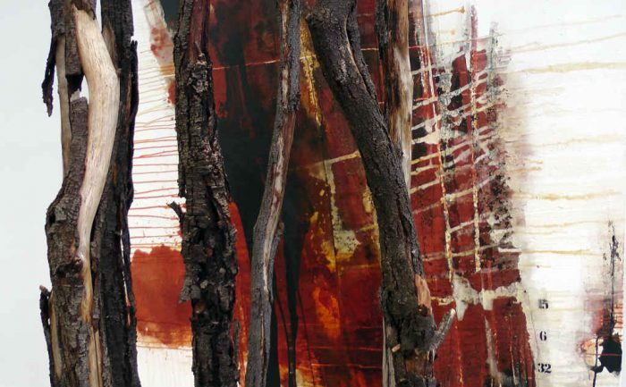
"AN UNCONFIRMED NUMBER"
https://www.youtube.com/watch?v=q6B3LxBbYLk

This series is a continuation of the exploration of Eucalyptus trees, but in this series I explored the ideas of acacia pycnantha and eucalyptus leucoxylon species and the way that they express a dialogue with contemporary Aboriginal culture in Australia.
My son and I are playing together on this. He makes music and intuitive decisions, it was a really special experience having us make this together- my didgeridoo and his piano in combination.
In this series there are 9 images 1 black and 1 white. You decide where it ends and where is starts. You decide how you explore the space and how you see the journey, but there is a journey implied in the transition from black to white. Each canvas is exploring the way the british invades the aboriginal landscape and culture.. The way that you go around the exhibition is like a cycle as visual marks that express the idea of violence build on the surface. I have included numbers- which come from the "official" figures on of deaths- as they dehumanise the events. It is is not a record of the individuals that were lost, but the sum total. Poured acrylic and oil fight on the canvas as freer and angry, I made sure to use quick marks to support that idea.
To be able to get the expression in the marks that I made, I had to produce lots and lots of preliminary pourings for the canvas. I explored what my marks expressed and built on the ideas.
He was also doing explorations in movement to pour the paint how he wanted. PHYSICALLY engaging.
Horizontal lines created by pouring paint replicate the scarification that is traditional in aboriginal adolescents. These marks are seen as brutal and not seen well outside of the group.
relationship of space in the exhibition replicated the idea of the exhibition and the way that it is explored. The phobias and the way that you see the work is happening differently.
When I was curating I wanted to make sure that I negotiated the space to improve the viewers' understanding of the work. I made trees block their way so they had to move close to the work. The people were forced into spaces to be closer to the work and confront the physical surface. This reinforced the idea of the surface being important.
Questions from students:
Why trees and when trees start being important in your work?
I am interested in the physical landscape of Australia. Went to university in the city, I loved the city, my dad was a keen gardener so I had been around nature but never felt a connection to it. When I left home and took my first teaching position it was up in the north (near the center of Australia). It was the first time that I actually saw the Australia bush and the real landscape. I could see the whole sky and it was open and not closed any more. I could see the big world. We would camp out and sleep out on the ground. I was able to experience and appreciate the bush in a new way. At this point I was only 21/22 but it didn't come into the art practice for a while. It doesn't always make an impact yet. It was when I was in Borneo, as it was years since I saw those trees and landscape that I began to use it again.
Every painting is a learning journey as you don't know where it will take you.
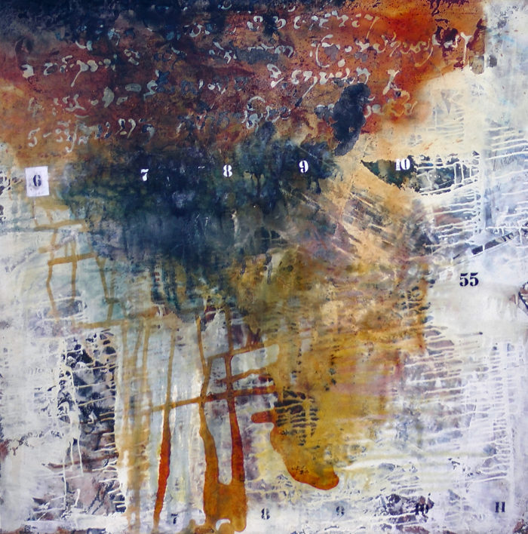

tuol sleng – silent walls
With this series it was about how I was able to find beauty in the walls and the nature in these horrific places. I loved how nature was completely forgiving and began to overtake and erase the history on the walls. Nature has moved those people on and it has a wonderful way of reclaiming the spaces.
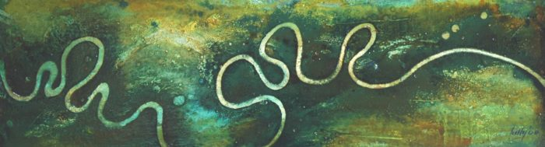 Turkey Creek
When I think of spaces and places, I see things from an aerial perspective. It is how I express or explore space in my mind.
When I draw, it is in black and white- colour doesn't have to be used even there does not have to be a full spectrum in the paints I didn't really make this connection until later. I always felt that all the colours needed to be used as there were so many available, but I could keep my drawings simple and black and white.
These series are based on river beds and the way that they carve through a landscape.
You mentioned about the artist responding, should we look for one thing to create out our work from? Does it need to be different?
You should never stick with your first idea, if you have only ever done one and look at things in lots of different ways and explore. A mistake isn’t a failure, it is about a step to the next one. If you are too concerned about the what could go wrong, and be more concerned about what could happen. Engage everything and move with confidence. The line you make can be more confident.
Art is an extension of you and is a way of you to come out. If you 'try' to be something else, you will see that you are not being you, but if you take inspiration and make it your own then you need to tell your truth and be confident. Make a thousand lines until it becomes true.
Does an artist have to have a deadline and how do you react if you don't like all your work at the deadline?
What if there is a deadline at the exhibition and you don't like the work that you have produced?
An artist doesn't always work to a deadline. Things can take years before they are rediscovered and created again. I need to have a goal, but I can change the work as I decide to, I can leave a painting, or leave an idea and return to it later- days, months, years.. I can decide that a painting would be better as a drawing or a sculpture and pursue that instead.
If in a space and there are room for 15 paintings, and it's not necessarily the 10 best that I will choose, but the ones that belong together – that make sense as a conversation. Work that holds the idea of synergy. The idea of synergy is found when the body of work together says more than the individual pieces. Together they say more.

